Q. 1 Grade Checker

Take a score as input and print the grade based on the following:

90+ : "A"

80-89 : "B"

70-79 : "C"

60-69 : "D"

Below 60 : "F"

🡪

def grade_checker(score):

if score >= 90:

return "A"

elif score >= 80:

return "B"

elif score >= 70:

return "C"

elif score >= 60:

return "D"

else:

return "F"

score = int(input("Enter the Score : "))

print(f"The Grade is : {grade_checker(score)}")

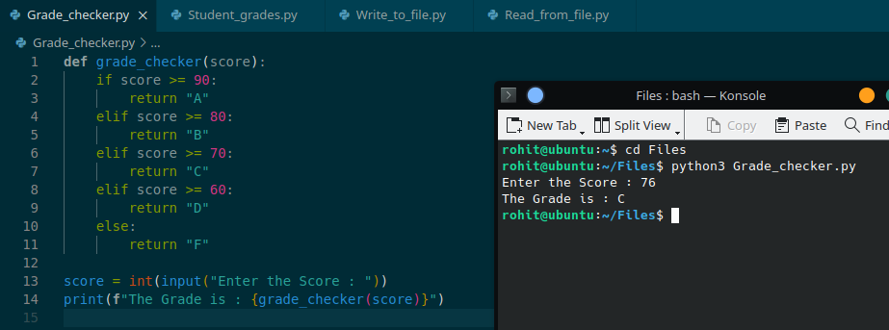

Q. 2 Student Grades

Create a dictionary where the keys are student names and the values are their grades. Allow the user to:

Add a new student and grade.

Update an existing student’s grade.

Print all student grades.

Used dictionary and basic operations. Using if else:

🡪

def student_grades():

grades = {}

while True:

action = input("Choose an action: add, update, print, or exit : ").strip().lower()

if action == "add":

name = input("Enter Student Name : ")

grade = input("Enter Student Grade : ")

grades[name] = grade

print(f"Added {name} with grade {grade}.")

elif action == "update":

name = input("Enter Student Name to update : ")

if name in grades:

grade = input("Enter new Grade : ")

grades[name] = grade

print(f"Updated {name} grade to {grade}.")

else:

print("Student not found.")

elif input == "print":

for name, grade in grades.items():

print(f"{name} : {grade}")

elif action == "exit":

break

else:

print("Invalid action. Please Choose Again")

student_grades()

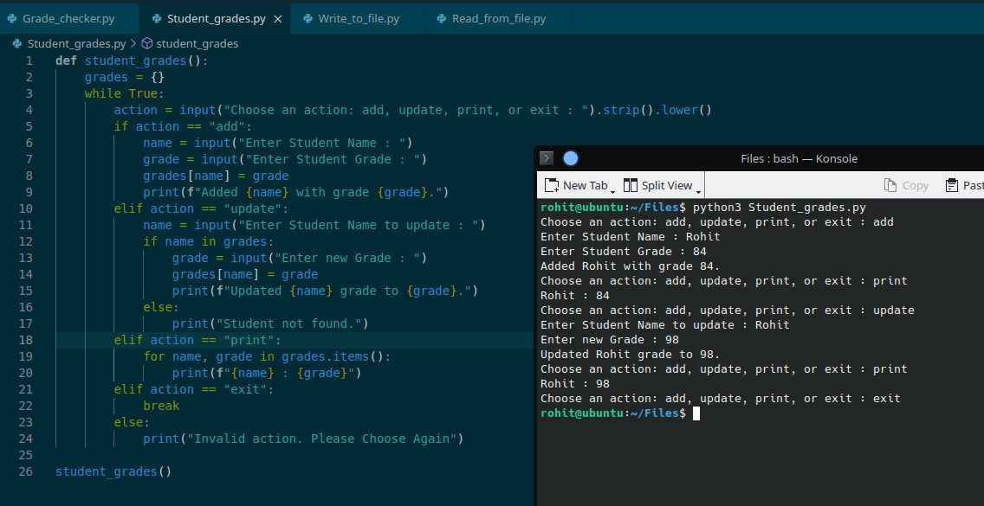

Q. 3 Write to a File

Write a program to create a text file and write some content to it.

Using file functions like write and open.

🡪

def write_to_file(filename, content):

with open(filename, 'w') as file:

file.write(content)

print(f"Content written to {filename}.")

a = input("Enter File name : ")

b = input("Enter content : ")

write_to_file(a,b)

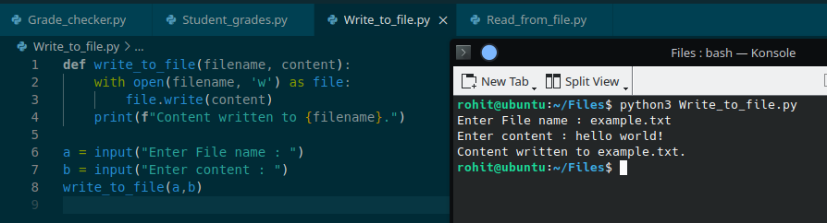

Q. 4 Read from File

We used open in read mode and file.read to read and print to display.

🡪

def read_from_file(filename):

with open(filename,'r') as file:

content = file.read()

print(content)

a = input("Enter file name : ")

read_from_file(a)

